**Samson Kangangi David**

Samsidavid7@gmail.com

Abstract

{A Project of the next best way of solving one of the main issues affecting parent, guardians and children}

[FIND MY KID APP]

[For lost and found children]

“Knowing isn’t enough.We must apply. Being willing isn’t enough. We must do.”-Angus MacGyver.

**Declaration page**

I hereby declarethat this project report is original.

Student sign:

__________________

Lectures sign:

__________________

**Table of contents:**

Chapter One--------------------INTRODUCTION Pg 3-4

Chapter Two--------------------EVALUATIVE REPORT

Chapter Three------------------PROJECT METHODOLOGY

Chapter Four-------------------SYSTEM ANALYSIS AND REQUIREMENTS

MODELING

Chapter Five-------------------

Chapter Six--------------------

Chapter Seven-----------------

References-----------------------------------------------------------------------------

Appendix------------------------------------------------------------------------------

**CHAPTER ONE:INTRODUCTION**

1. **Introdution;**

An Android project/application on helping parents and guardians find lost children.

The main idea is that a parent posts his/her lost child’s photo and details to the platform.Any random person that finds a lost child can also post and with a similarity in the name and or description. An alert the pops on both adults’ phones and through the authorities they both meet and the child is handed to the parent.

1. **Background of the study;**

Basing my study from my background and environment, i’ve seen parents and guardians toil all around the Eastlands of Nairobi visit every police station, chiefs’ office and all other authoritiy offices. However, the authorities through the **Children’s Department** is taking a rather small step in aiming to curb this issue. They contain a database the contains details of all the children that have been lost and those that have been found. I also hope that they may be one of my clients because through my applicatio i could grasp an opportunity and get access to their database and possibly add my data to them this will be of great help and as they will be also keeping records.

1. **Problem Statement;**

Parent and guardians have been having trouble,lots of it, when it comes to reporting and searching to find their lost children.Parents and guardians get frustrated as they take alot of time and effort running and rushing to the authorities, but they get stuck in waiting rooms and long queues just to get some service. However, this isn’t enough,the only effort taken here is just writting a statement of the lost or found child. The parent later on has to toil all over carrying a photo of the child and asking random people if they have seen the child.

1. **Objectives ;**

My key objectives for this projects is to first take the first week to plan the projects design and interface then investigate all about the **Children’s Department** and how they function. In mid july this year, start with the development of the first phase of my project i.e.User authentication and progress though out the course of that month and august with developing the entire application. Later in the final week of august perform my analysis of the project and debug all the errors that may have occured and run its beta version.

1. **Scope and limitations**

The expanse of this project is kimited to a number of areas:

* The application is used mostly with mobile phones i.e. smart phones with an internet connection.
* During the project deployment initially, the intended audience of the app are strictly residents of kenya.
* The app is restricted to mainly citizens.

1. **Justification**

Both the police and childrens departments are looking for ways to curb and make an end to the issues of child abductions and children getting lost.finding the easiest way to help these topic is by creatingg an broadcast to show such cases.

Having a system that manages and stores everycase that has been reported on such issues.

1. **Budget and resources.**

|  |  |  |
| --- | --- | --- |
| Resources | | Amount in Ksh |
| 1 | computer | 50,000 |
| 2 | Cloud Database charges | 1000 |
| 3 | Personnel | 45,000 |

*Figure 1: budget and resources*

**CHAPTER TWO:EVALUATE REPORT**

1. **Introduction**

This section provides an evaluative report done after extensive reasearch as a driving force toward getting to comprehend the nature of online broadcasting ,unlimited database storage and provide a clear case and provide the project’s context.

1. **Elementary statement**

Advanced technology has made it posible to do a lot of things online at the comfort of our home by thr click of a button ,technologies like the Amber Alert which is an emergensy messege that is issued when a law enforcement agency determines that a child has been abducted and is in imminent danger.

**CHAPTER THREE:PROJECT METHODOLOGY**

1. **Introduction**

To be able to manage and achieve the goals of this project agile software development methodology is used, this is a methodology based on iterative development where requirements and solutions evolve throughout the software development life cycle of the project with development and testing activities being carried out concurrently.

It employes continual planning, learning, remodeling, adaptive prototyping and early delivery which encourages flexible responses to change.

1. **Reasons for agile software project methodology**

* Software development process is broken down to individual modules that are easy to work on
* Expect and copes better with changes in technology trends
* Increases the quality of deliverables
* Efficiency
* Every iteration has its own testing phase hence allowing regression testing every time new functions or logics are released.

1. **Overview**
2. Planning
3. Definition of requirement
4. Desinging and prototyping
5. Software development
6. Integration and testing
7. Deployment
8. Operations and maintenance
9. **Planning phase**

During the idealization and problem identification, I evaluated the terms of the project by calculating material costs, creating a timetable with target goals and defining the projects’ architectural structure.

A feasability study was conducted to ensure that the project is leagally and technically viable,this was done in stages.

*Technical feasibility*

An analysis of the technical requirement needed for the development,testing and implementation of the project was done the results were compared to available resources to be able to determine whether the resources meet the technical required for the project.

Evaluation of software, hardware and other technical requirements of the proposed web application was done and as a result the reports derived from the study indicated that the idea is technically feasible as most of the resources needed are readily available.

*Economic feasibility*

Questionnaires and face to face interviews with parents and some few administrative workers within Nairobi county were conducted to determine the viability, cost and benefits associated with the project before financial resources are allocated. An analysis of the findings stipulated that the financial benefits the project brings to the table outrank the cost of development. From a law point of view few police officers from my region potrayed that the project would be a rising star in a technologically evolving nation.

*Scheduling feasibility*

Data science prediction algorithms were used to analyze the stages involved from the start of the

project to its implementation in relation to the given timeframe to determine whether the project will be completed in time and also estimate how much time each project stage will take to complete.

1. **Definition of requirements**

After an approaval and go ahead of the project ,the requirement for the development process were defined and acquired.

*Hardware Requirements*

Computer:

* 8gb Random Access Memory (RAM)
* 500gb Hard Disk Drive (HDD)
* Intel Core i5 Processor

*Software Requirement*

* Android Studio
* Graphics Editor/designor (Adode Photoshop)
* Stable internet connectivity.

1. **Deisgning and prototyping**

*Architecture*

At a higher level the application achitecture will involve three main core componenets,system administration, drivers and clients. From the three componenets respective subcomponenets will be modeled to fullfill all functionality requirements of the app.

*Programming*

Language, libraries and frameworks to be used in the development process:

* **Kotlin**

The core programmming language of the application is kotlin.

Kotlin is a cross-platform,statically typed,genereal-purpose programming language with type interece.it is designed to interoperate fully with Java and the JVM version of kotlin’s standard library dependc on the java class library,but type inference allows its syntax to be more concise.

* **Firebase for interaction with the firebase database**

Firebase helps you build and run successful apps. Backed by google, loved by developers.

Accelerate app development with fully managed backed infrastructure.

*Communications*

The application will use emails and messaging services to communicate with its users.

*Security*

Google authentication as well is built in security protocols including SSL traffic encryption, password protection, and secure storage of user credentials will be just but a few of the many security measures to be implemented in the application.

1. **Software Development**

This is the actual writing of the program, the development of the application will be subdivided into small independent modules, each module will be developed independently and later integrated into the master application. A video showcasing a quick guided tour of the applications basic features that display on the first launch will also be developed at this stage.

1. **Integration and Testing**

*UI testing*

The application will run locally on my physical device, where manual testing of the user interface by checking on various display pages will be done.

*Security Testing*

A simulation of the production environment will be created in order to carry out security tests and build counter measures as response to any security threat that might arise in the real production environment.

1. **Operations and maintenance**

Once the development process is complete, Throughout the use of the mobile application by consumers in the production environment, I will continually receive both positive and negative feedbacks via the applications contact page and various social media sites, in case of an arising bug that was not captured during the testing phase I have tasked myself with fixing the bug by going through all the underlined development stages. In a period of a month after the application is launched for use, i will still be tasked with research and improvement of the applications features for a continuous integration to meet up-to date and new emerging user-needs.

**CHAPTER FOUR:SYSTEM ANALYSIS AND REQUIREMENTS MODELING.**

1. **Analysis method**

For the analysis of the current system,a systematic structured analysis was employed in order to understand, analyze and refine the objectives of the existing system and develop a new system specification that solves the problems faced by the current system.

1. **Understanding Problems Posed by the Current system**

Child abductions and dissappering at this time and also during the past years is somewhat a horrible vice. In the old systems there isn’t a platform that connects parents/gurdians with fellow citizens that might have probably come through a reported missing child.

In kenya as a country having a nice and progressive grasp in technology around major cities in the country has proven to be a challenge ,the current methods do not offer:

* + Technical support
  + Reliable database storage space
  + Minimal interactions in administrative offices

1. **The Proposed system**

The idea of an online mobile application for childeren abduction and missing cases is to aid parents and citizens to easy ways to find their kids via smart phones from any location.currently parent have to toil to administrative offices and search for their children.

The **LostKid** project aims to brigde the gap between parents, gurdians, citizens and the childrens deparment by:

The mobile appp aims to solve the congestion problems by providing woried parents and guardians with the best and easiest way to use and provide,real time geolocation to improve data analytics.

The new developed system functioning through a mobile application will be run con-currently with the old system to ensure smooth transition.

1. **Functional Requirements**

A functional requirement is often defined as a behavior of the system that takes input and provides output. The LostkKid mobile application it should allow both a parent and citizen to create an account.

Parent reporting of their lost child will:

* Create an account
* Post details of the child including a photo,name,age and last clothes the child was on.
* If a match was possible the parent will be notified
* Have a technical support call from authorities to pick up the child with a specified location.

Citizens who have found a lost child will:

* Create an account
* Post an immediate photo,name(optional depends on the age),age/age estimate,location where found and clothes last on.
* If a match is found ,notification goes to the parents contact
* Have a technicall support call to deliver the child in a specified location.

Add user

Remove post/uers

Manage system users

Citizen login

Citizen

Register

Parent login

Parent/guardian

login

Administrative module

1. **Admin**

An administrator is a critical component of the mobile application. For a reliable and successful operation of the app, the admin has full control over the application’s functionality and full access to all its information. In modeling the requirements for a system administrator, the following duties and responsibilities will be designed and tasked to the application’s system admin.

❖ Setting up new users and giving them restricted access to the information

❖ Managing and maintaining file servers ❖ Employing latest security protocols

❖ Updating the application with fresh content about offers and new products available

❖ Approving drivers

❖ Delete/Deactivate user accounts for both drivers and clients.

❖ Produce reports on orders and application usage

The flowchart below represents the flow of information in relation to its sequence of functions for the system administrator.

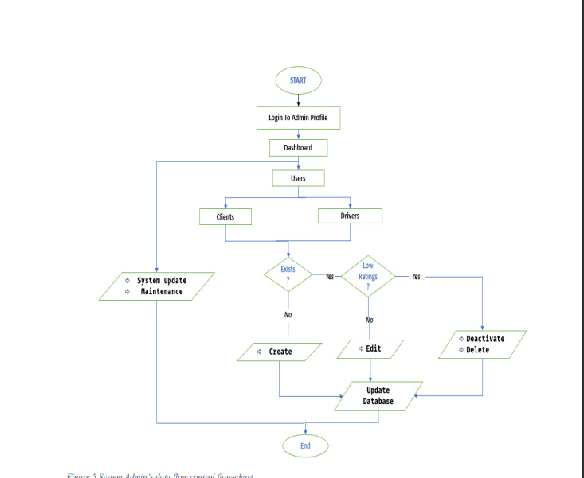

**CHAPTER FIVE:SYSTEM DESIGN**

1. **Entity Relationship Diagram**

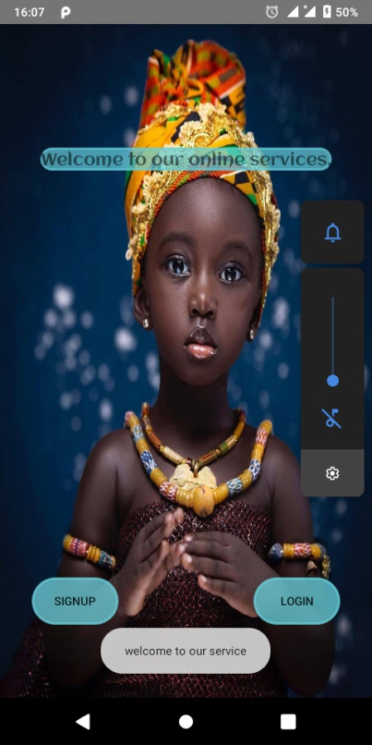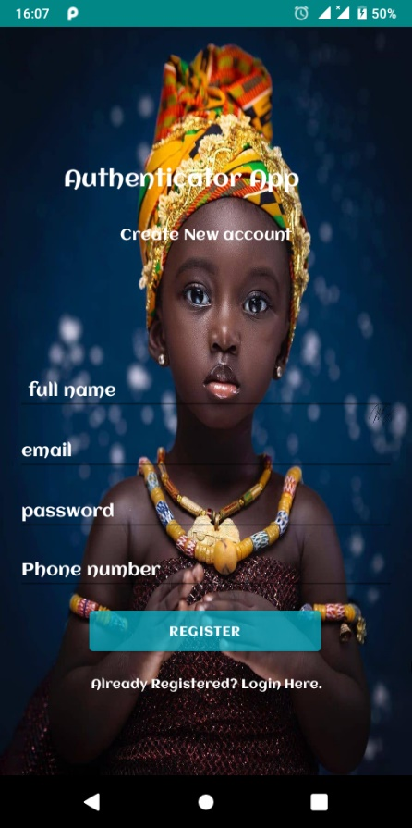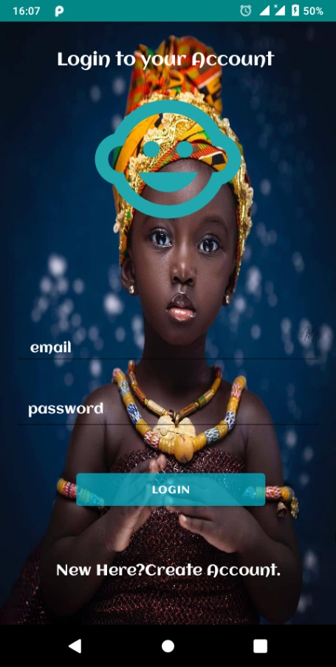

**CHAPTER SIX:SYSTEM IMPLEMENTATION**

1. **Introduction**

Lostkid is a mobile app designed to help improve find children and end issues of child abduction.A parent signs up and is verified by the phone number.here he/she will be able to post his/her lost child’s details .while on the other hand a normal citizen who has found a lost child can post the details of the child and with a match in the childrens depertment, both parties meet at a convinient place and the child is handed to the parent/guardian.

1. **User interface**

The user interface design is developed by integrating the use of Google’s material design patterns implemented by the UI library material-ui and React.js a popular UI design framework. The application is made up of folders and files encapsulating the many components that together make up the different pages of the application. All components are built using the function component syntax, with a little bit of a super touch from material-ui library and most of the styling done with react styled components to abstract styling from functional implementation of individual components.

To be able to manage rendering different components and the application being a multi user system, redux is used to provide, manage and update the applications state in a predictable manner.

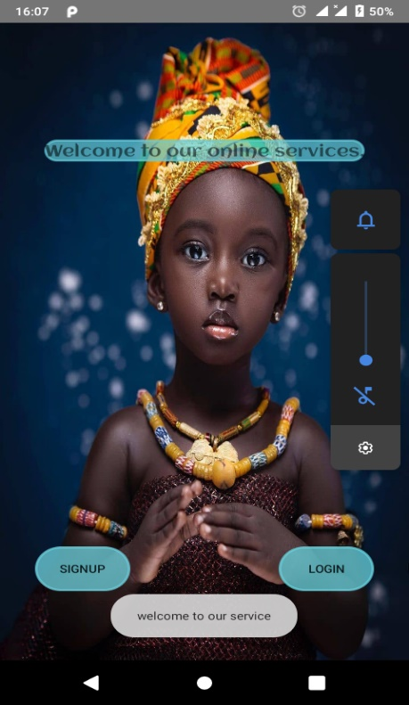

**CHAPTER SEVEN: RECOMMENDATIONS & LIMITATIONS**.

* 1. **Recommendations**

With regards to the ever-advancing patterns in technology, to further improve the application and keep it in the leading atmosphere within the competitive business market, there are a number of recommendations to consider.

❖ Develop a native mobile application for major mobile operating systems like android and mac as the target audience has a larger percentage of users accessing the application through mobile devices

❖ Integrate More payment systems like PayPal and credit-card to improve ease of paying for services and offer a wide range of choices that a user can use the applications monetary related features

❖ Add an Option to chat within the app - Live chat within the app with customer support would be great. Sometimes you have a quick question or need, but then you have to complete a support ticket and wait for a reply. Having an on-demand customer service will be a huge improvement that many users would appreciate

❖ Include more in-ride details like current weather – The application can include more info pertaining to the trip, like weather delays, etc. in the future to make the experience better.